The Vision

In order to enhance the productivity and efficiency of our software engineer’s work, we are introducing a new hardware/software combo to keep track of their daily activities. In terms of hardware, this new device will look similar to a smart phone, but it will be a little bigger. Its size will be in between the size of a standard smart phone and a tablet, but a lot thinner. On the software side, not only will this device be their name badge and pass card, but it will also keep track of current files that they will be working on, as well as schedules, meetings, emails among other important information pertinent to each employee. The goal is to create an intuitive device that will allow our software engineers to accomplish more with less effort, hence increasing efficiency and productivity.

There are two features of this device that we believe will provide flexibility to our engineers. On feature is the Integrated Development Environment built into the device. It is not a full development suit, but it provides powerful tool to modify codes or libraries on the go, providing instant visual feedback of the changes made. This will allow our engineers to quickly accommodate modifications and have the visual representation as they talk to a client.
The other feature is our digital drop-box. This is not a new concept but we feel that it is a powerful tool for our engineers to share what they are working on with other engineers as well as client, provided the client has the proper clearance to access the drop-box. This will potentially eliminate file redundancy, which in turn will increase productivity.

Our device will work exactly like a modern smart phone in the aspect of having a full touch screen, porting practically all the functionality that one would expect from a touch screen device, including but not limited to, swipe gestures, accelerometer motion detection, and voice recognition. On the other hand since the device will have a larger screen real-estate, we are employing more functionality on the display screen with a reasonable amount of customization, something that is not as efficient on, for instance, a smart phone due to its smaller screen dimensions.

As previously mentioned, the device will resemble a smart phone in its architecture. Its exact dimensions will be length: 3.5 inches, height: 5 inches, width: 0.30 inches. The effective touch screen dimension will be 3 inches, height: 4 inches. This device also will be equipped with three built in buttons, one to bring back to the home screen, one back button, which jumps back to the previous screen on the stack, and a menu button, that will prompt the user with the menu pertinent to the screen he/she is currently viewing. The device also is equipped with one 3.0 Megapixel front facing camera, and a 5 Megapixel rear facing camera, one rear mono speaker and one front microphone. It will have a standard USB connection, a Micro SD slot, a multi functional full duplex auxiliary port (a cable with multiple connection adapters is provided), and lastly a power button.

User Profile:
- Diverse cultural characteristics;
- High motivation;
- Positive attitude
- English as native language
- College reading level
- High typing skills
- Advanced Degree education
- High computer literacy
- Expert system experience
- Expert task experience
- Frequent use of other systems
- Fast paced performance
- Software engineer
- Comfortable working under pressure

Draft questionnaire
- Do you consider your self a leader or a follower?
- Do you normally accomplish your tasks with a positive attitude?
- Do you rather have some one tell you your tasks or are you an autonomous person?
- Do you speak any languages besides English?
- Do you have a bachelor’s degree or more in Software Engineering or a related field?
- How comfortable are you working with a enterprise software suit?
- What type of systems have you worked with in the past?
- Are you a fast paced worked or you prefer to take you time when accomplishing a task?
- Do you feel pressured if a task must be accomplished in a certain time frame?

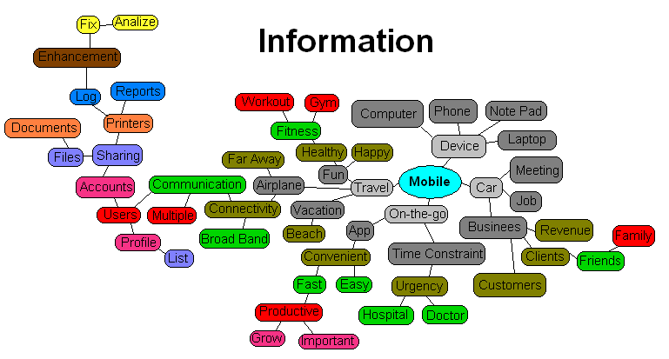

Tasks
- Travel arrangement
- Meeting arrangement
- Fast interactivity
- Easy to learn
- Various list displays
- Profile
- Users
- Account management
- Sharing
- Documents
- Files
- Print
- Report
- Log
- Communicate important events
- Connect on the go
- Productive tools
- Business enhancer
- Customer satisfaction
- Phone portability
- Auto bug report
- Log of every task accomplished
- Client Mock-up view
- Wifi enabled
- Hot spot device
- Schedule keeper

